Tito Musyoki Rural Community Development Organization
Greetings TM Community,
Merry Christmas and Happy New Year,
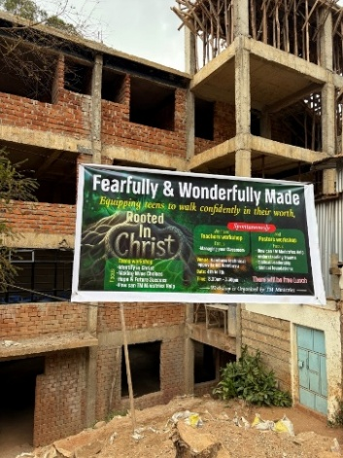
The end of the year has come already and we would like to share highlights of 2025. The mission trip from Radiant Church was very successful in August. The hand of God was on the entire trip as we saw 30 people give their lives to Christ.
We were pleasantly surprised to see 100 teens attend ‘The Fearfully and Wonderfully Made’ seminar. The number of teens grew each day of the three-day seminar. All of them were excited about the teaching and many asked if we could come back. This was our first event held specifically for teens. One of the groups in attendance was the soccer team from Ngunyumu Christian Center/Church Plant. The 16-member soccer team only had 2 members attending church before the seminar, but after the seminar all 16 began attending church.
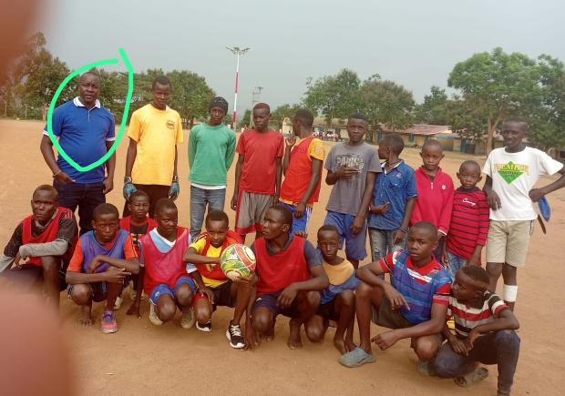
The soccer team presently has 22 members of which 9 players are fully funded. Five of the new players are girls. Thank you to all who generously supported the team. Another highlight for the Christian Center was another successful VBS which included the kick-off of a new phonics reading program. A local school teacher is tutoring the kids on a regular basis at the Christian Center.
The soccer coach is circled
One new well was installed in Kambusu. This well is servicing the community and the Kambusu Christian and Vocational Training Institute (Kambusu Training Center). The third-floor classrooms are finished. We are beginning to work on the restrooms.
We look forward to seeing what God has in store for T.M. Ministry in the coming year. Thank you all for your faithfulness to this ministry and may God richly Bless you in 2026.

